Name Date Period

**Chapter 10 Map and Butch Cassidy**

On the map you will be locating Utah’s early colleges, railroads and early mining towns. To save space you will not be required to label everything.

Follow these directions to complete the map on back.

1. Using the maps on page 186, 187 draw in Utah’s early railroads. Use only one color, and don’t label any of the railroads or towns along the way.

2. Using page 197 you will be labeling Utah’s colleges and universities. *Locate and label* these eight colleges and universities on the map, use the current name (in parenthesis). The map on page 9 will help you find the location of the towns

3. Locate and label the location of Utah’s early mining towns.

Butch Cassidy; page 204, 205

With the good also comes the bad. Butch Cassidy and the Wild Bunch are among the most famous/infamous of old west outlaws. Robert Parker, later named Butch Cassidy was from southern Utah. Complete the chart below outlining his *robberies*.

|  |  |  |
| --- | --- | --- |
| What was stolen | Location of the robbery | Year (when it says) |
|  |  |  |
|  |  |  |
|  |  |  |
|  |  |  |
|  |  |  |
|  |  |  |

What happened to him?

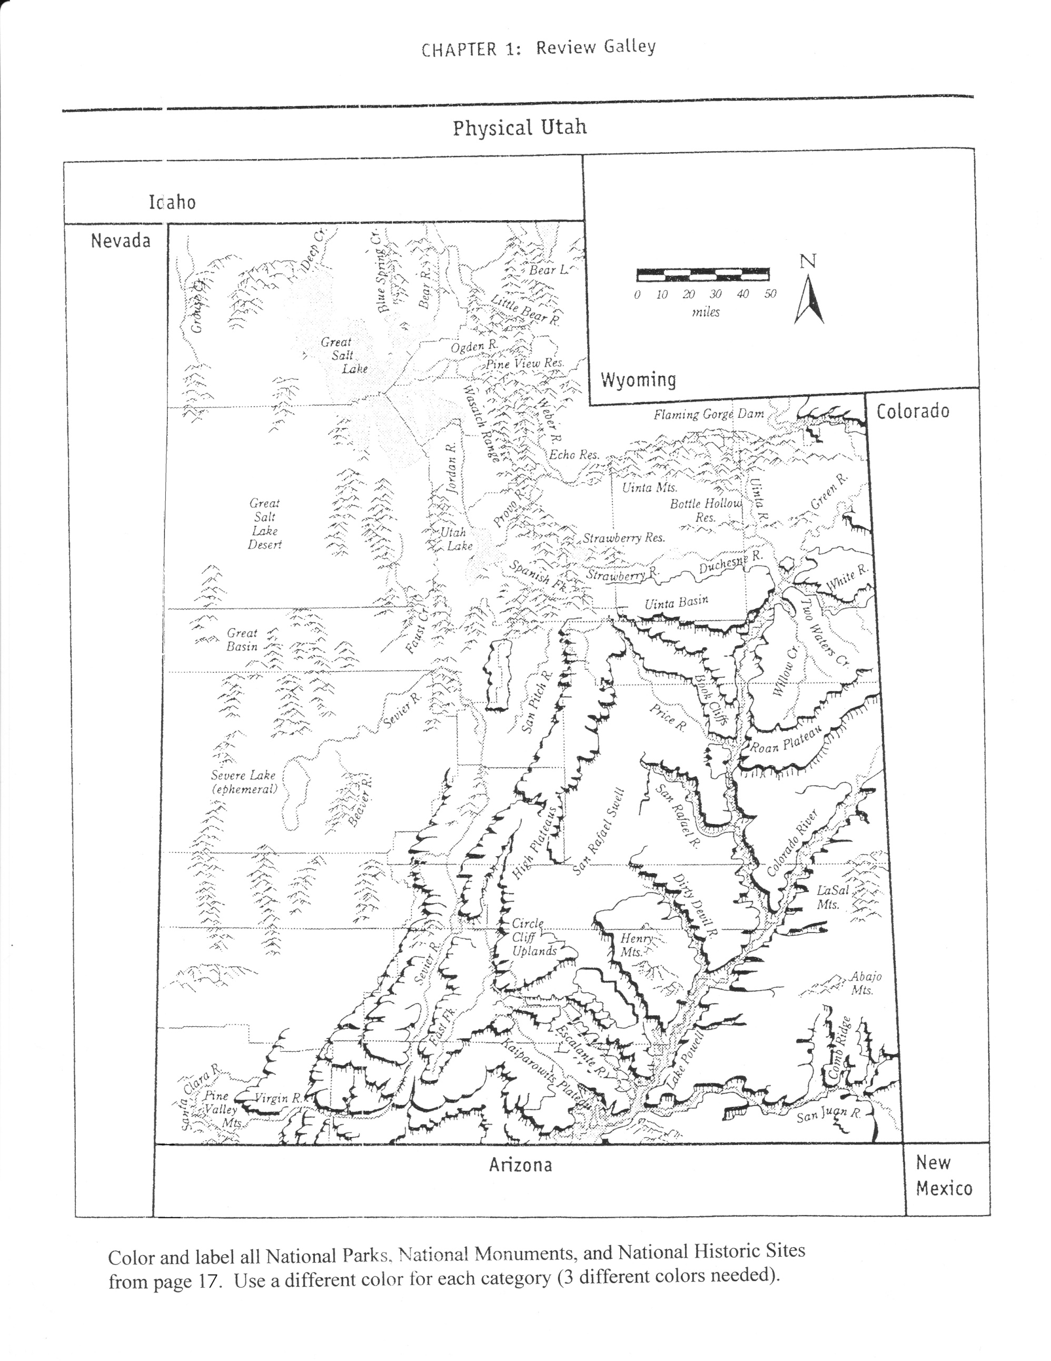

Railroads

Colleges, Universities 

Mining Towns 