Name Date Period
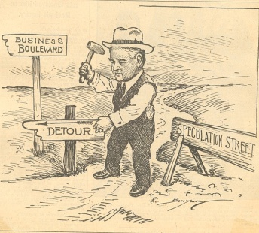
The Great Depression Begins PowerPointQuestions
Begin with slide 6

1. 1928 presidential election electoral votes
Hoover =
Smith =

2. How was the stock market performing through most of the 1920’s?

3. What does it mean to buy stocks on margin?

4. On “Black Tuesday” what happened to people to bought “on margin?”

5. There is a run on the banks. How many banks have failed by 1933?

6. What is the unemployment rate in 1933?

7. What was the purpose of the Hawley-Smoot Tariff?

8. How much did world trade drop because of the Hawley-Smoot tariff?

9. Provide an example of how the depression was even harder on minorities.

10. How many farmers lost their land?

11. What caused the dust bowl?

12. Which five states had the worst dust storms?

13. Define hobo:

14. Why was President Hoover slow to react to the depression?

15. What famous dam was built during this depression?

16. World War 1 vets had been promised a bonus to be paid in 1945. Many of them march on Washington hoping to collect early. What happens to them?

